

Residency Renewal-Web

نظام تجديد الإقامة

Requirement Document

V.1.0

Frontend

Web App

for

Residency Renewal

# **Front End Web App for Residency Renewal Services**

## Login

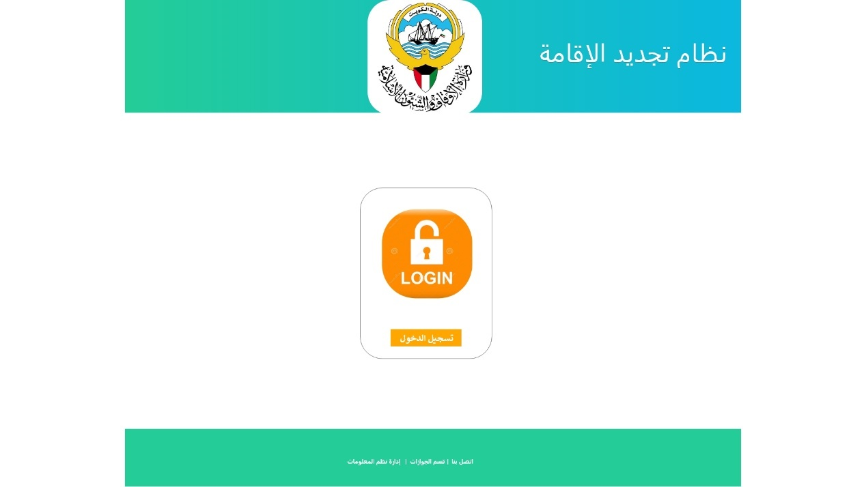

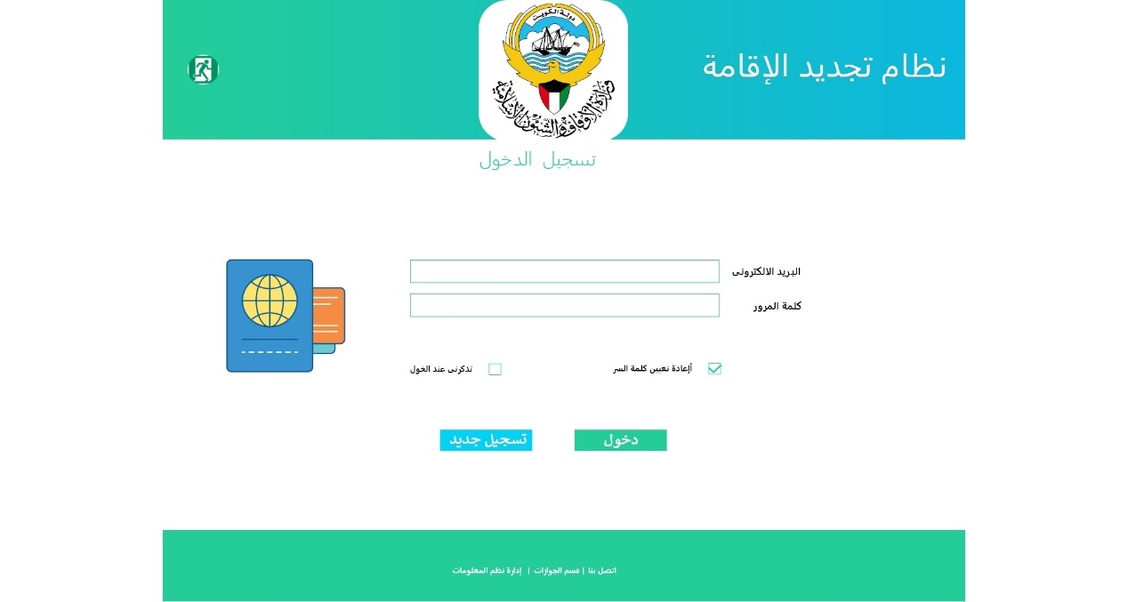

|  |  |  |
| --- | --- | --- |
| Type | Arabic Field Name | English Field Name |
| Mandatory, Textbox, Email Format, by Default its MOA Employee Email  Or  Register email in Residency Renewal System | البريد الالكتروني | Email |
| Mandatory, textbox, and password of MOA Employee Email  Or  The Register password in Residency Renewal System | كلمة المرور | Password |
| Action Button to login into Residency Renewal System  By default, any Employee has MOA Email and Password should login into system | **دخول** | **Login** |
| Button to add new registration recorded in Residency Renewal database for any employee doesn't has MOA email or not exist in SAP database. | **تسجيل جديد** | **New Register** |

## New Register

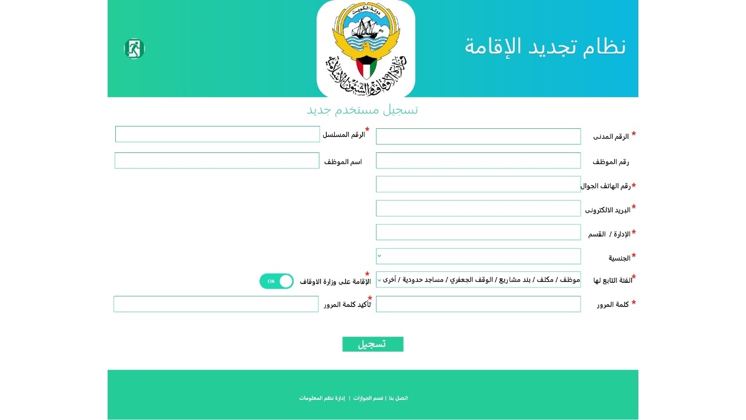

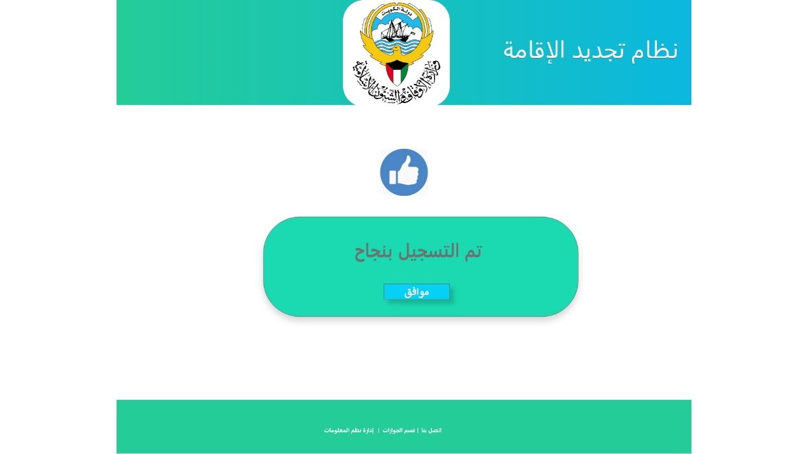

|  |  |  |
| --- | --- | --- |
| Type | Arabic Field Name | English Field Name |
| Mandatory, textbox, and should valid ID with 12 number | الرقم المدني | Civil ID |
| Mandatory, textbox, valid serial Number from PACI and not less than 12 number | الرقم المسلسل للرقم المدني | Civil ID Serial Number |
| Auto Retrieved Employee Number from SAP HR System | رقم الموظف | Employee Number |
| Retrieved, Textbox, Mandatory if it's not retrieved | الاسم | Name |
| Retrieved, Mandatory with 9 number | رقم الهاتف | Mobile Number |
| Mandatory, Textbox, Email Format | البريد الالكتروني | Email |
| Auto Retrieved, and Dropdown list (from SAP HR MOA organization structure) and Mandatory one value to be selected if not retrieved | الإدارة / القسم | Sector / Department / Section |
| Auto Retrieved, and Dropdown list and Mandatory one value to be selected if not retrieved.  And System should allow to register only Employee with Non-Kuwaiti Nationality | الجنسية | Nationality |
| Mandatory Dropdown list (Maintained in Residency Renewal system database)   * موظف * مكلف * بند مشاريع * الوقف الجعفري * مساجد حدودية * أخرى | الفئة التابع لها الموظف | Employee Type |
| Mandatory Flag (Yes / No)  And System should allow to register only Employee with Yes Flag | الإقامة على وزارة الاوقاف | Residency by MOA |
| Mandatory, textbox, and with at least 8 alphanumeric characters | كلمة المرور | Password |
| Mandatory, textbox, should matched with password field | تأكيد كلمة المرور | Confirm Password |
|  |  |  |
| Button to add new registration recorded in Residency Renewal database  The System shouldn't Register any employee already exists in SAP HR System database, or has civil id or emp id or email in SAP database.  The Resister Only for any employee his record not exist in SAP HR database  The System shouldn't allow any duplicated recodes in Register for the same:   * Civil ID * Emp Number * Phone Number * Email | **تسجيل** | **Register** |
| System Generate Number for this request | رقم التسجيل | Registration Number |
| System will Capture date and time for this registration | تاريخ التسجيل | Registration date |
| Mandatory and system generated status:   * New: Once the record Generated and Registration successful * Accepted: by the Sys Manager * Rejected: by the Sys Manager * Closed: by the Sys Manager | حالة التسجيل | Registration Status |

## Initiate New Application

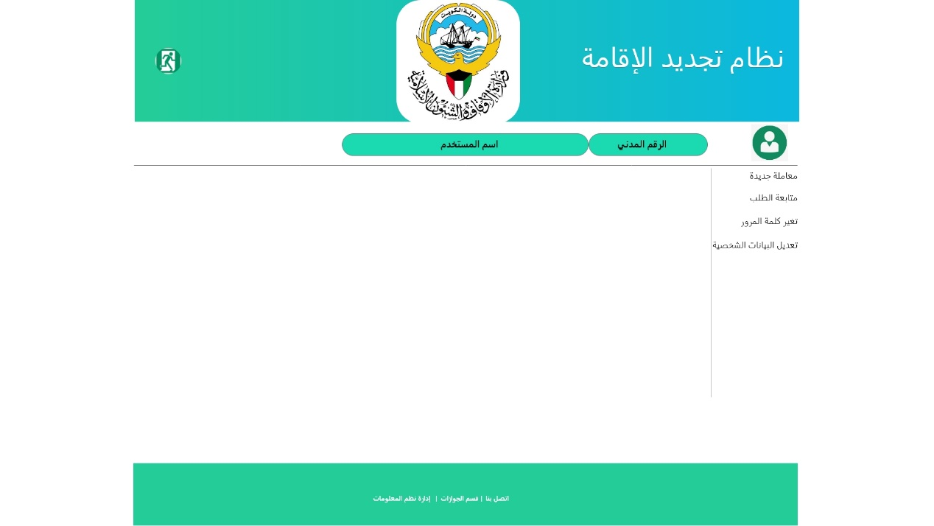

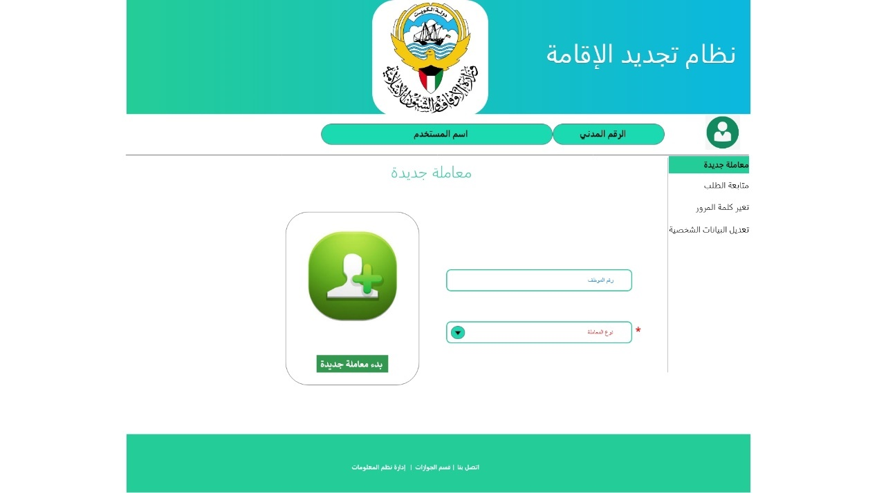

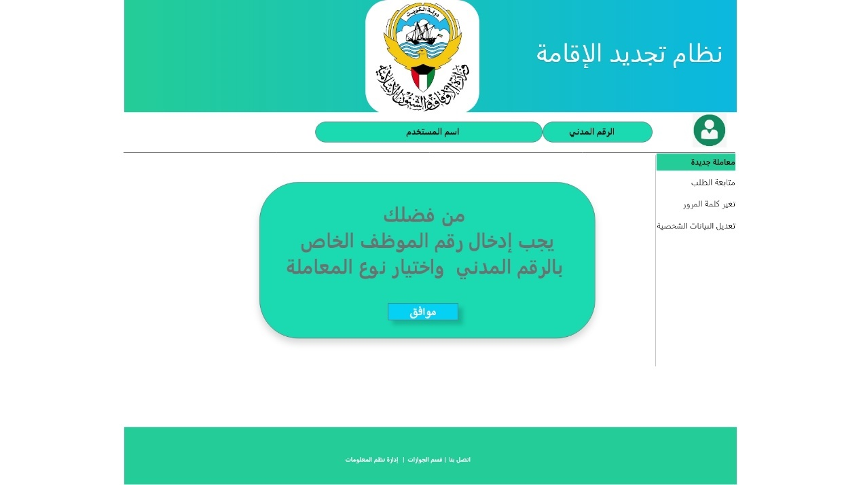

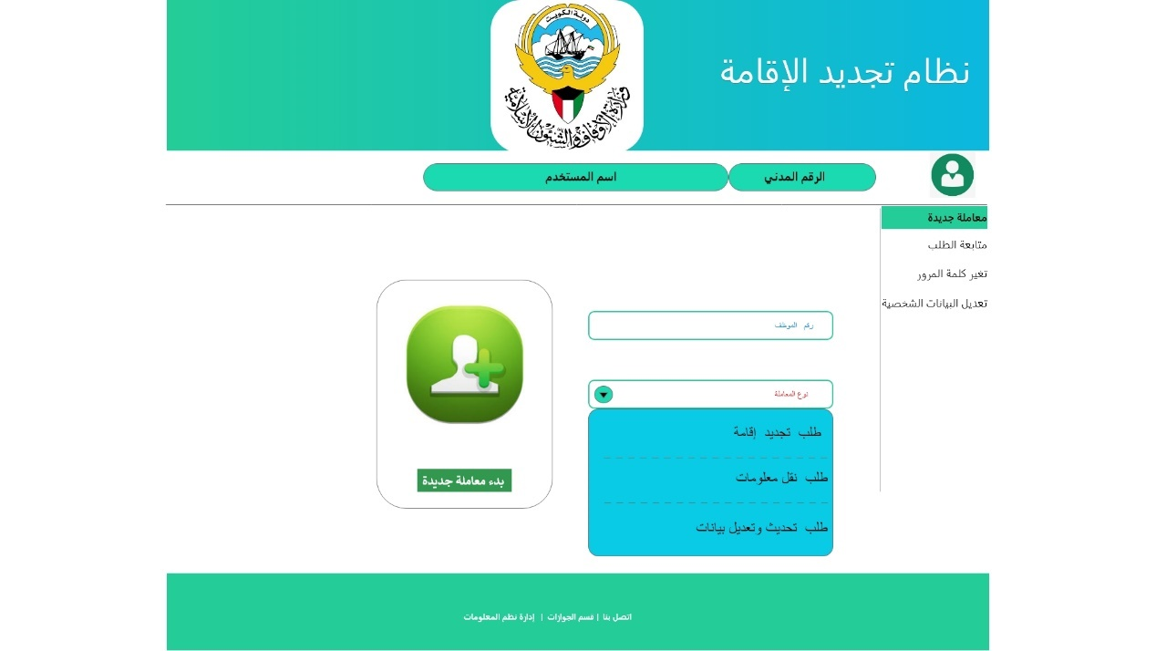

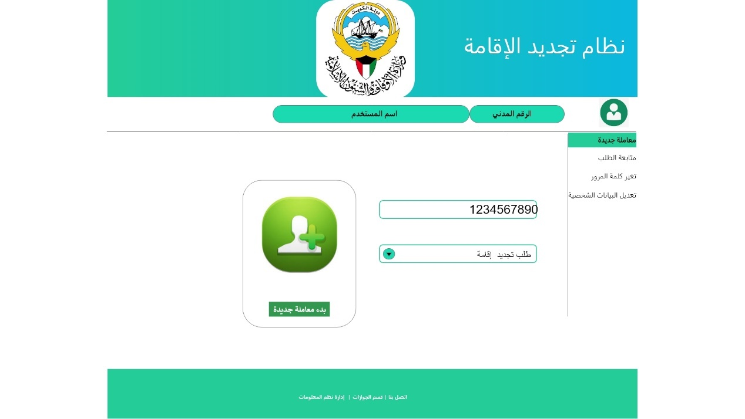

|  |  |  |
| --- | --- | --- |
| Type | Arabic Field Name | English Field Name |
| Mandatory, textbox, and should valid ID with 12 number | الرقم المدني | Civil ID |
| Retrieved, Textbox, Mandatory if it's not retrieved | اسم المستخدم | Name |
| Auto Retrieved Employee Number from SAP HR System | رقم الموظف | Employee Number |
| Auto Retrieved Employee Number from SAP HR System | رقم الموظف | Employee Number |
| Mandatory, Dropdown list, list of all Active working services that (Maintained in Residency Renewal system database)   1. طلب تجديد اقامة 2. طلب نقل معلومات 3. طلب تحديث او تعديل بيانات 4. تمديد إقامة 5. الغاء إقامة | نوع الخدمة | Service Type   1. Renewal Residency 2. Transfer Information 3. Update Information 4. Extend Residency 5. Cancel Residency |
| Button to Start Create and fill new application Form | **بدء معاملة جديدة** | **Start Create Application** |

## Create New Application

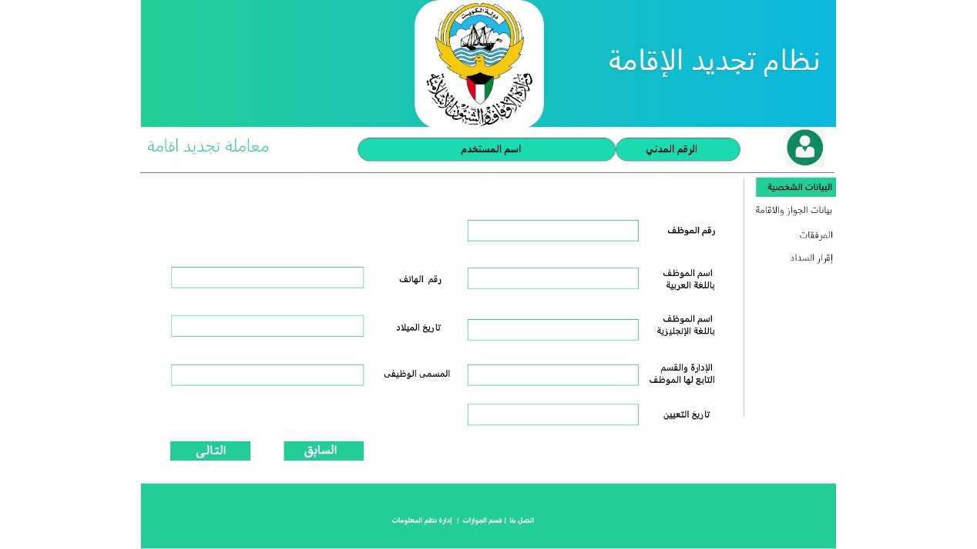

Personal Information Page Header

|  |  |  |
| --- | --- | --- |
| Type | Arabic Field Name | English Field Name |
| Retrieved the selected Application Type | نوع المعاملة | Application Type |
| Retrieved, Textbox, from login information | الرقم المدني | Civil ID |
| Retrieved, Textbox, from login information | اسم المستخدم | Name |

Personal Information Page

|  |  |  |
| --- | --- | --- |
| Type | Arabic Field Name | English Field Name |
| Auto Retrieved Employee Number from SAP HR System | رقم الموظف | Employee Number |
| Retrieved, Mandatory, Textbox, From PACI , and can be editable if not retrieved | الاسم باللغة العربية | Employee Name - Arabic |
| Retrieved, Mandatory, Textbox, From PACI , and can be editable if not retrieved | الاسم باللغة الانجليزية | Employee Name- English |
| Auto Retrieved, Date Format and can be editable if not retrieved  Should matched with Civil ID | تاريخ الميلاد | Birth Date |
| Retrieved, Mandatory with 9 number, and can be edit | رقم الهاتف | Mobile Number |
| Auto Retrieved, Mandatory and Dropdown list (from SAP HR MOA organization structure) and Mandatory one value to be selected if not retrieved | الإدارة / القسم | Sector / Department / Section |
| Auto Retrieved, Mandatory, Textbox and can be editable if not retrieved | المسمى الوظيفي | Job Title |
| Auto Retrieved, Date Format and can be editable if not retrieved | تاريخ التعيين | Hire Date |
|  |  |  |
| Validate all Mandatory Fields, Then Save information, Go to Follow up service | السابق | Pervious Page |
| Validate all Mandatory Fields, Then Save information, Go to Passport Page Information | التالي | Next Page |
|  |  |  |
| System Generate Application Number for this request | رقم المعاملة | Application Number |
| System will Capture date and time for this Application and this date will be updated once the all page information is completed | تاريخ المعاملة | Application date |
| Mandatory and system generated status:   * Initiate: If only all mandatory personal information is valid and saved * New: Once all required Pages are valid and filled * Approve: by the Sys Manager * Reject: by the Sys Manager * Return: by the Sys Manager * Complete: This status will be changed from Return to Pending once the user complete it and send it back for approval | حالة المعاملة | Application Status |

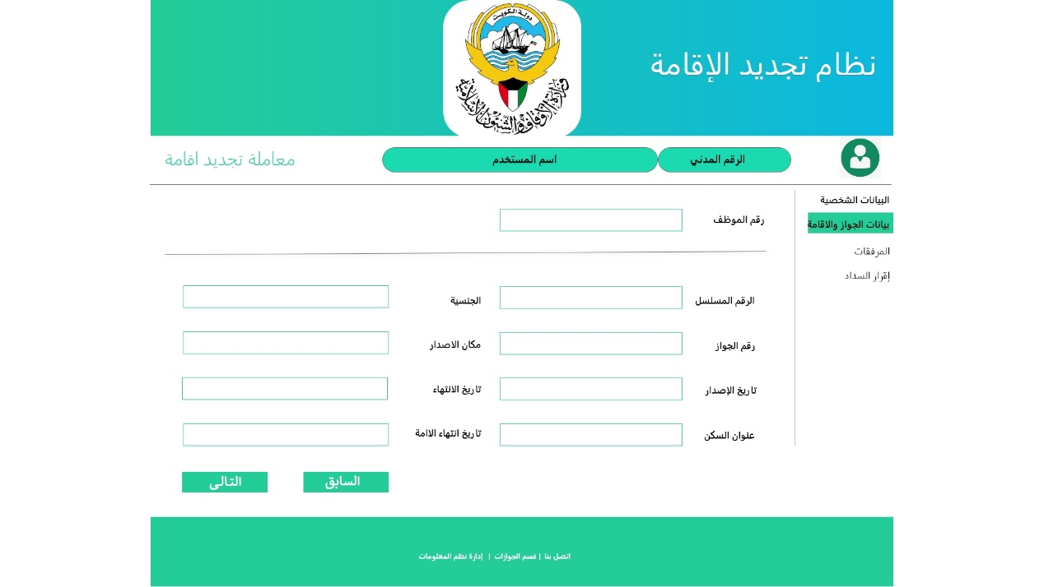

Passport Information Page Header

|  |  |  |
| --- | --- | --- |
| Type | Arabic Field Name | English Field Name |
| Retrieved the selected Application Type | نوع المعاملة | Application Type |
| Retrieved, Textbox, from login information | الرقم المدني | Civil ID |
| Retrieved, Textbox, from login information | اسم المستخدم | Name |
| Retrieved, Number, from Previous page information | رقم الموظف | Employee Number |

Passport Information Page

|  |  |  |
| --- | --- | --- |
| Type | Arabic Field Name | English Field Name |
| Mandatory, textbox, latest valid serial Number from PACI and not less than 12 number | الرقم المسلسل للرقم المدني | Civil ID Serial Number |
| Auto Retrieved, and Dropdown list and Mandatory one value to be selected if not retrieved.  And System should allow to register only Employee with Non-Kuwaiti Nationality | الجنسية | Nationality |
| Mandatory, Textbox | رقم الجواز | Passport Number |
| Mandatory, dropdown Country List | مكان الاصدار | Issue Country |
| Mandatory, Date Format | تاريخ الاصدار | Issue Date |
| Mandatory, Date Format | تاريخ الانتهاء | Expiry Date |
| Mandatory, Textbox | عنوان السكن | Address |
| Mandatory, Date Format | تاريخ انتهاء الاقامة | Residency Expiry Date |
|  |  |  |
| Validate all Mandatory Fields, Then Save information, Go to Personal Information Page | السابق | Pervious Page |
| Validate all Mandatory Fields, Then Save information, Go to Attachment Page Information | التالى | Next Page |

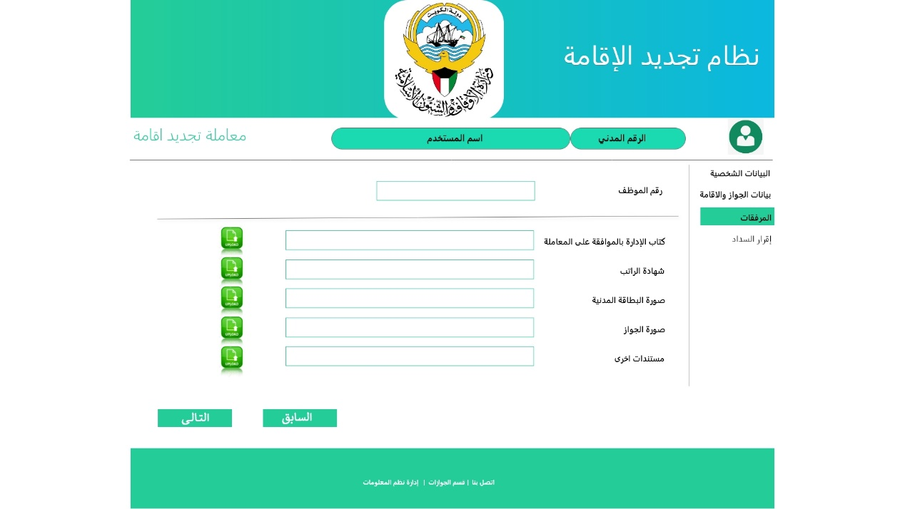

Attachment Document Page Header

|  |  |  |
| --- | --- | --- |
| Type | Arabic Field Name | English Field Name |
| Retrieved the selected Application Type | نوع المعاملة | Application Type |
| Retrieved, Textbox, from login information | الرقم المدني | Civil ID |
| Retrieved, Textbox, from login information | اسم المستخدم | Name |
| Retrieved, Number, from Previous page information | رقم الموظف | Employee Number |

Attachment Document Page

|  |  |  |
| --- | --- | --- |
| Type | Arabic Field Name | English Field Name |
| Upload PDF,JPG,PNG,Word document Size not large than 1 MB | كتاب الإدارة بالموافقة على التجديد | Approved letter for Residency Renewal |
| Upload PDF,JPG,PNG,Word document Size not large than 1 MB | شهادة الراتب | Salary Certification |
| Upload PDF,JPG,PNG,Word document Size not large than 1 MB | صورة البطاقة المدنية | Civil Id Copy |
| Upload PDF,JPG,PNG,Word document Size not large than 1 MB | صورة الجواز | Passport Copy |
| Upload PDF,JPG,PNG,Word document Size not large than 1 MB | مستندات أخرى | Other related documents |
|  |  |  |
| Validate all Mandatory Fields, Then Save information, Go to Passport Information Page | السابق | Pervious Page |
| Validate all Mandatory Fields, Then Save information, Go to Agreement Page Information | التالى | Next Page |

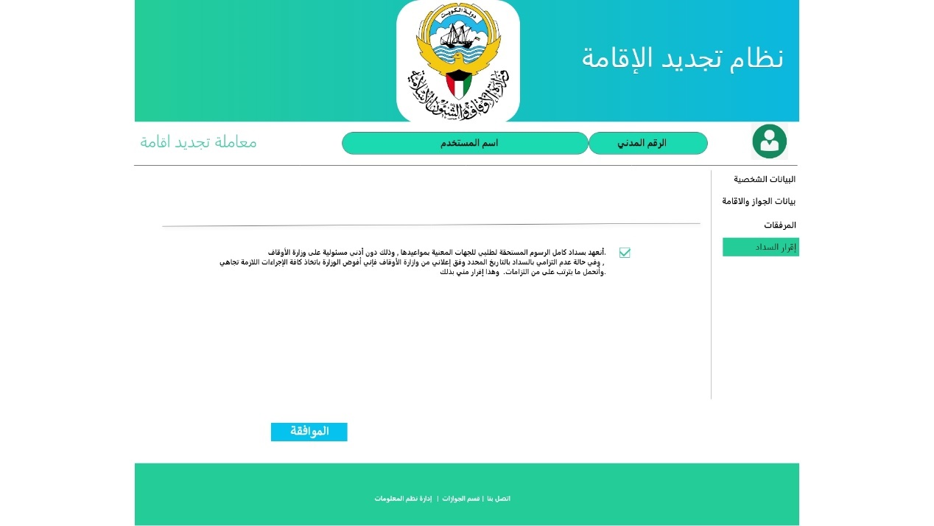

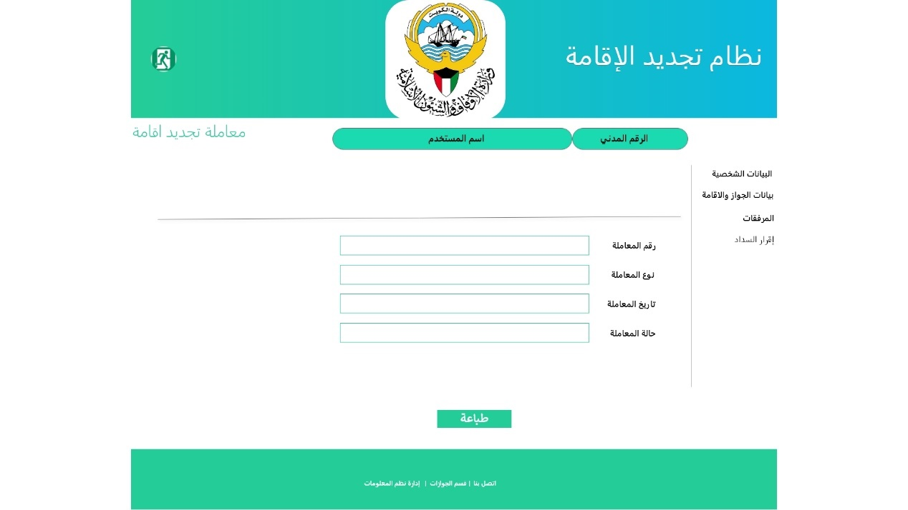

Page Header

|  |  |  |
| --- | --- | --- |
| Type | Arabic Field Name | English Field Name |
| Retrieved the selected Application Type | نوع المعاملة | Application Type |
| Retrieved, Textbox, from login information | الرقم المدني | Civil ID |
| Retrieved, Textbox, from login information | اسم المستخدم | Name |

One The user Complete Agreement page, the system will update the application status from Initiate to New Status and display the following information and can be printed

* + Application Number
  + Application Type
  + Application date
  + Civil Id
* Application Status

## Follow up Application

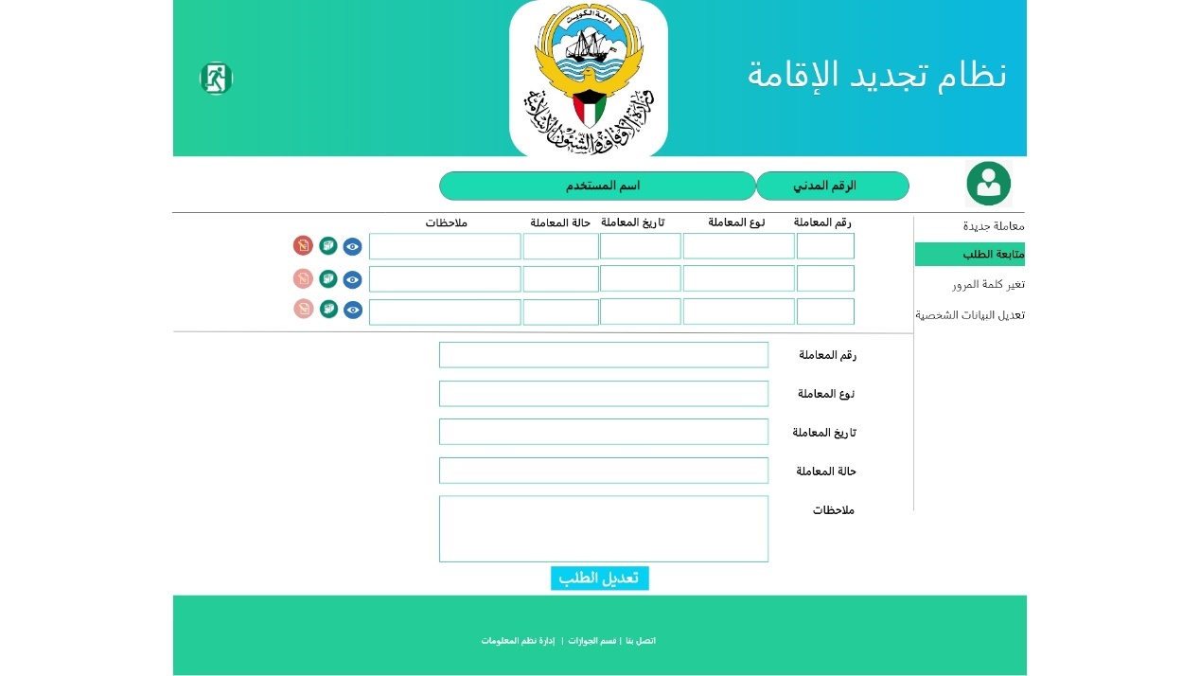

Page Header

|  |  |  |
| --- | --- | --- |
| Type | Arabic Field Name | English Field Name |
| Retrieved, Textbox, from login information | الرقم المدني | Civil ID |
| Retrieved, Textbox, from login information | اسم المستخدم | Name |

The user can follow up his application by select the follow up services and the system will display all his application in the following tabular From

* Application Number
* Application Type
* Application Date
* Application Status
* Remark

The user can do one of the following actions for each application:

* **View**: The user can review the entire application without allow to modified it.
* **Print**: The user can Print the selected application.
* **Re-Edit**: This action will be enabled only if the application status is **Return**, so the user can review the reason for return by read Remark field and updating or entering missing information then resend again from approval to system manager, the application status should change from Return to Complete.

## Re-Edit Application

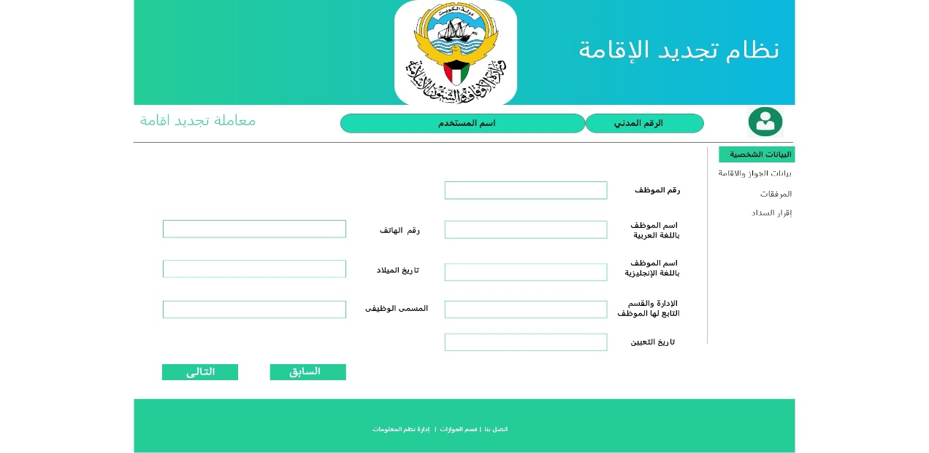

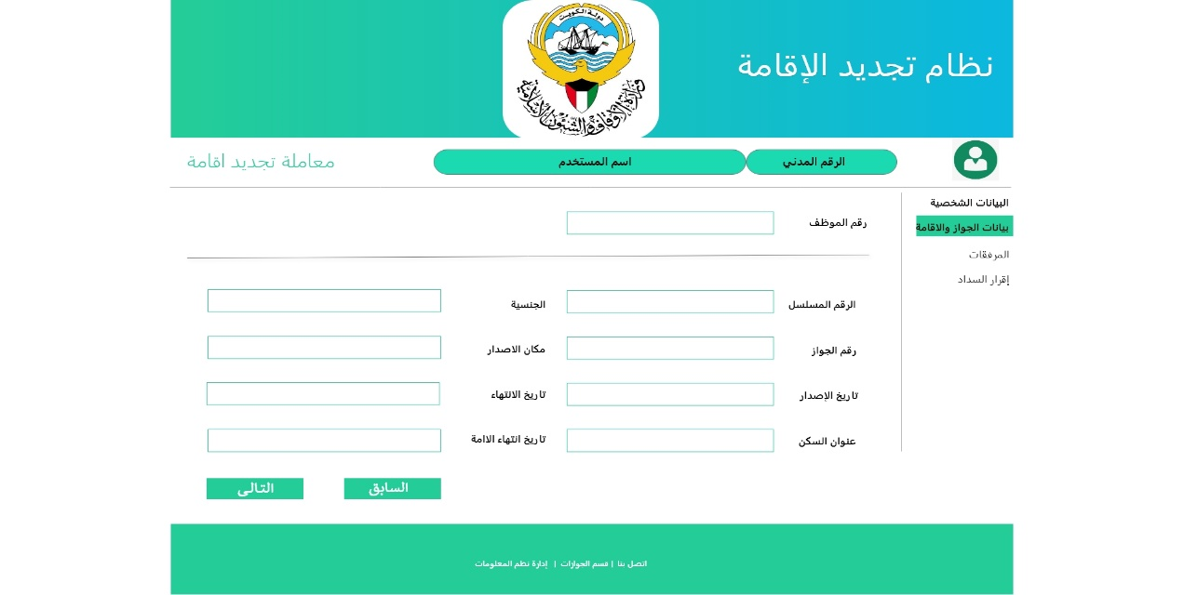

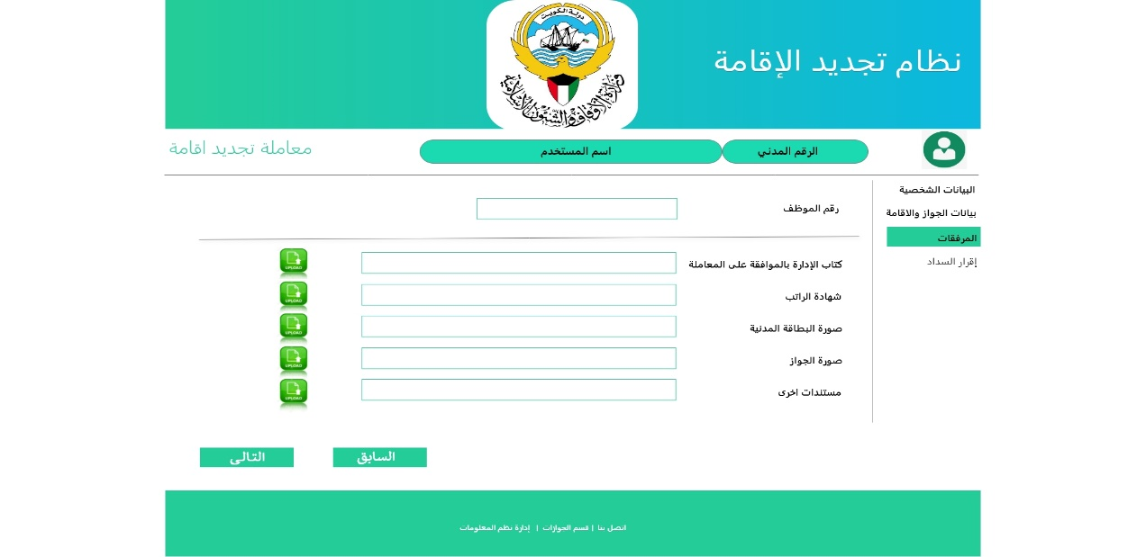

## Change Password

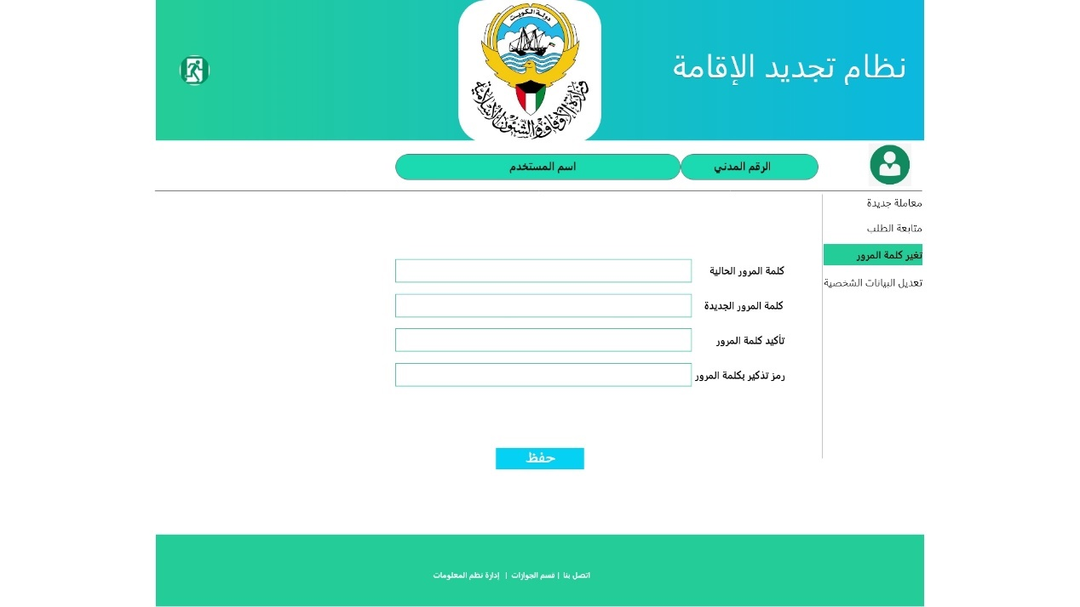

Page Header

|  |  |  |
| --- | --- | --- |
| Type | Arabic Field Name | English Field Name |
| Retrieved, Textbox, from login information | الرقم المدني | Civil ID |
| Retrieved, Textbox, from login information | اسم المستخدم | Name |

The user can use this service to change password and this service allowed for Registered users with External email only:

The MOA users who login with MOA email can change his password with normal change password procedure or contact the IT help desk , So that the new password should automatically reflect to Residency Renewal login

## Update Personal Information

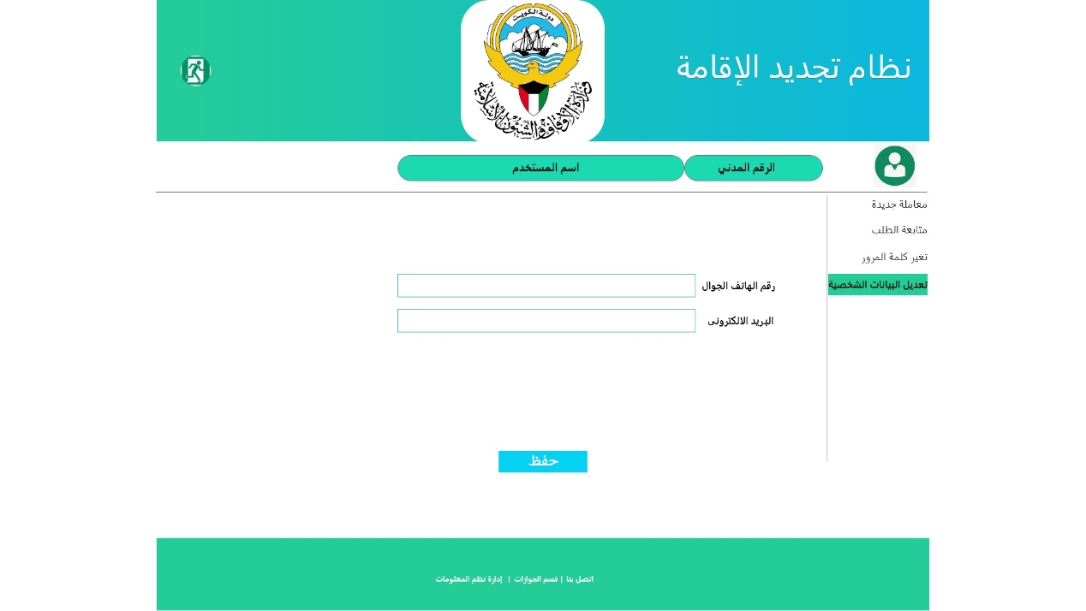

Page Header

|  |  |  |
| --- | --- | --- |
| Type | Arabic Field Name | English Field Name |
| Retrieved, Textbox, from login information | الرقم المدني | Civil ID |
| Retrieved, Textbox, from login information | اسم المستخدم | Name |

The user can use this service to update his personal information and this service allowed for Registered users with External email only:

* Mobile Phone number
* External email Only (The system shouldn't change MOA email)

## Front End Business Rules

1. The System should save the application information into different stages, so the user can complete the application in different time, but at least all mandatory personal information should be completed
2. The System shouldn't allow the user to create initiate new application from same type while there is any pending application (Initiate, New, Return)
3. Each Employee department can initiate / create any request on behalf of their employee

Backend

Web App

for

Residency Renewal

# **Back End Web App for Residency Renewal Services**

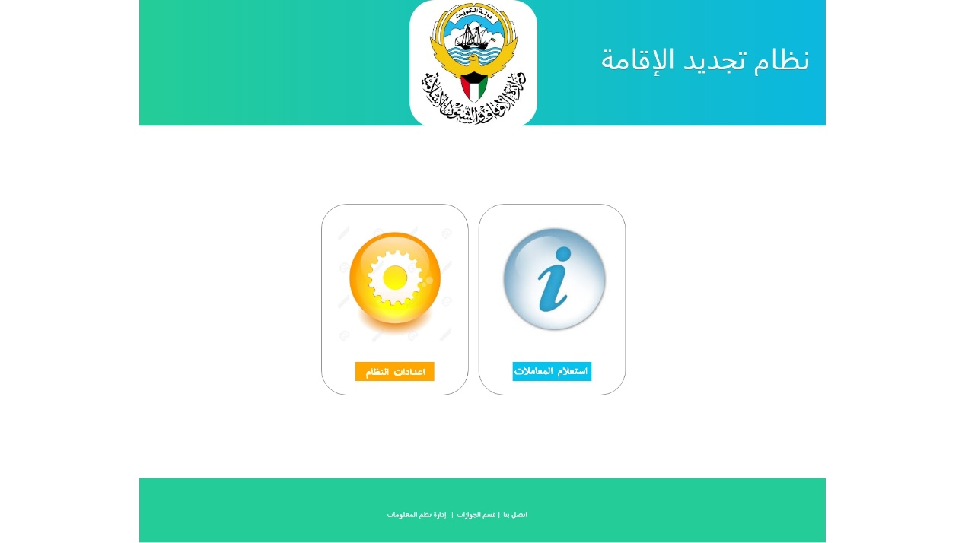

## Application Information

### Inward Application

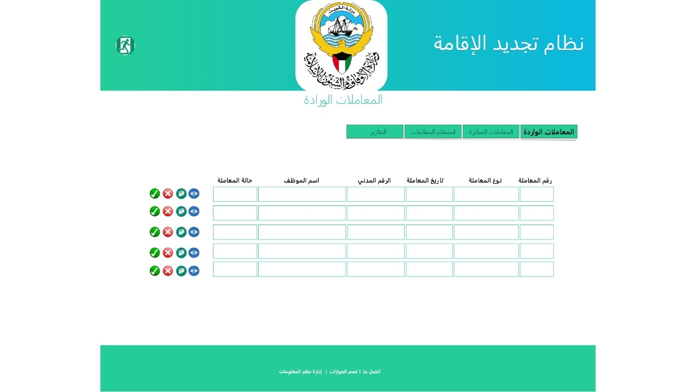

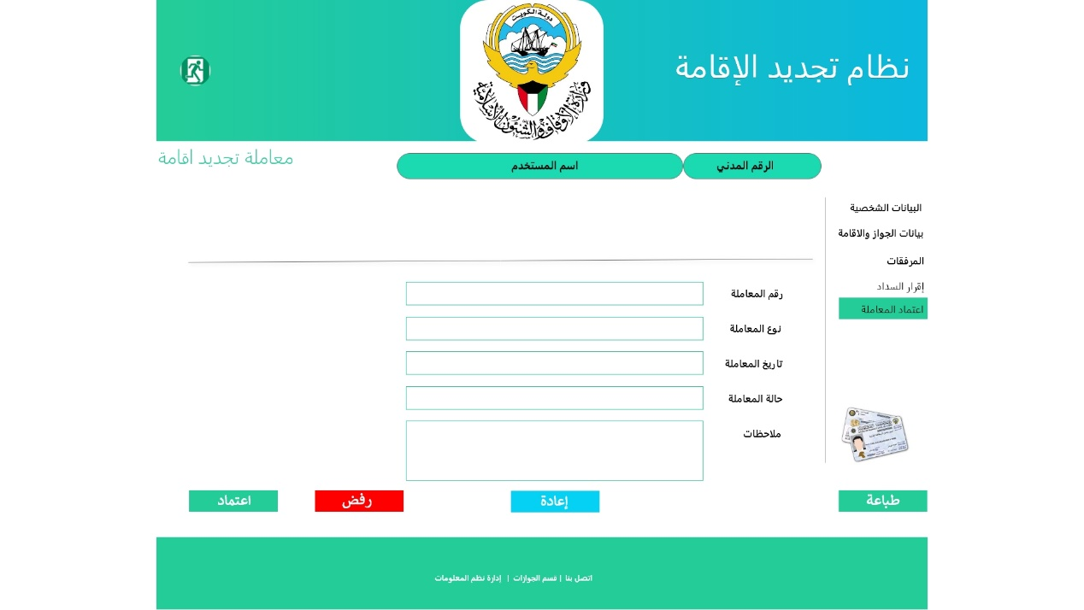

1. This service will retrieve all Applications with **New/Complete** Status in the following tabular Format:
   * Application Number
   * Application Type
   * Application date
   * Civil Id
   * Employee Name

* Application Status

1. The Service will allow for system Manager to do one of following functions for each displayed record **(View**-**Approve-Rejected** -**Print**)
   * View : The System manager can view the details of the application information for review the entire application information and verify it for one of the following decision :
     + Approve : The System manager can review and approve the application for the next stage for print it and enter it to MOI System ,update application status with **Approve** and notification sent to the applicant.
     + Reject: The System manager can reject the application with valid reason for rejection and update this reason in application Remark filed, update application status with **Reject** and notification sent to the applicant.
     + Return: The System manager can return the application again to the applicant with detail reasons with any missing information required from applicant and update these reasons in application Remark filed, update application status with **Return** and notification sent to the applicant.
   * Print : The System manager can Print the details of the application after approval to proceed enter it to MOI system.

### Outward Application

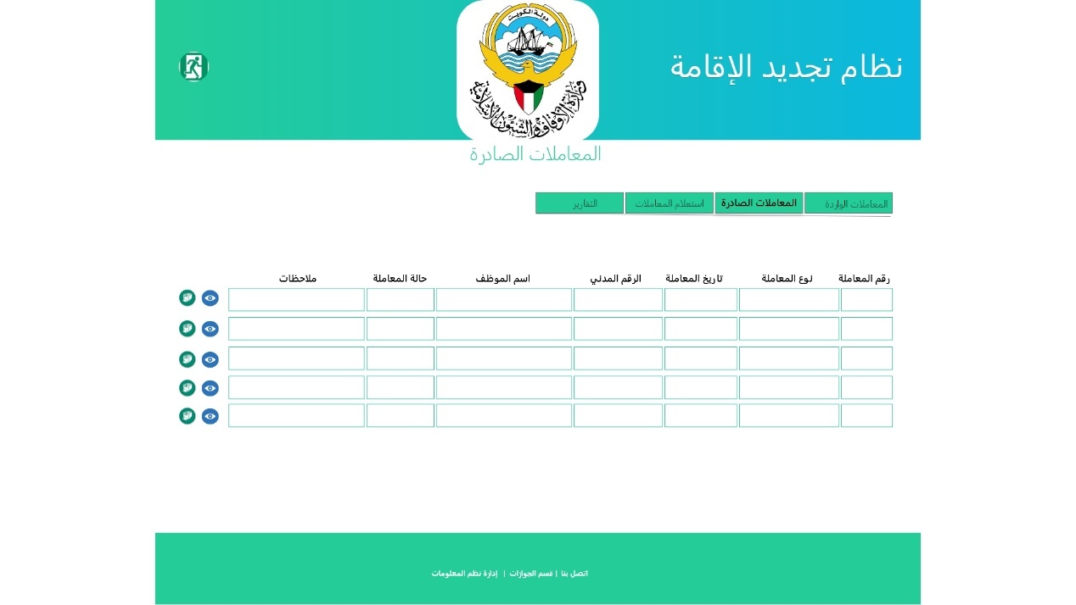

1. This service will retrieve all Applications with (**Approve-Reject-Return**) Status in the following tabular Format:
   * Application Number
   * Application Type
   * Application date
   * Civil Id
   * Employee Name

* Application Status
* Remark

1. The Service will allow for system Manager to do one of following functions for each displayed record **(View**-**Print**)
   * View : The System manager can view the details of the application information for review it or print
   * Print : The System manager can Print the details of the any application.

### Application Search

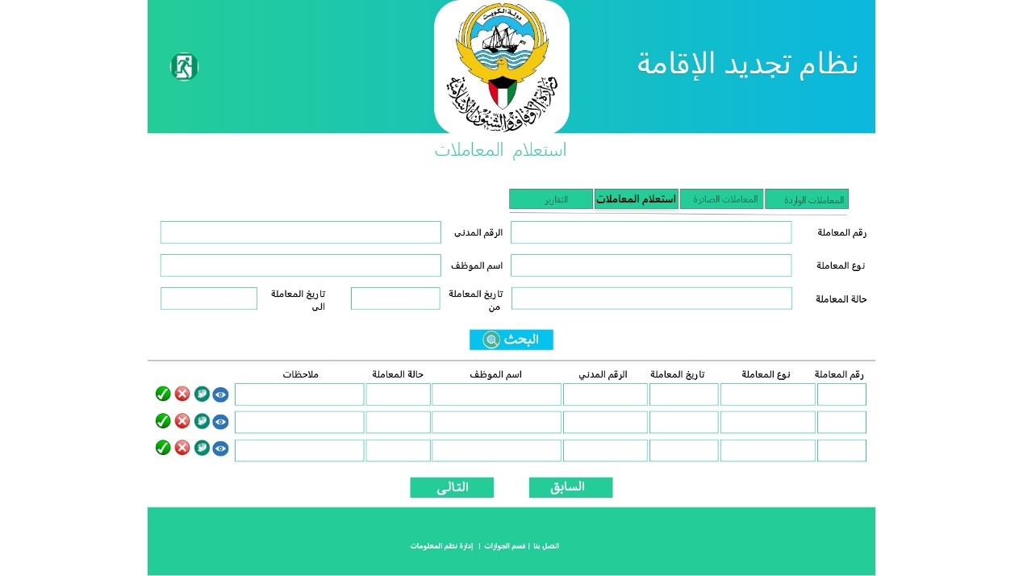

1. The System Manager can search for any Application by entering any for the following search criteria or combination:

* Application Number
* Application Type
* Application Status
* Civil Id
* Employee Name (Arabic Name)
* Application Date rang (From – To)

1. his service will retrieve all Applications according to search criteria in following tabular Format:
   * Application Number
   * Application Type
   * Application date
   * Civil Id
   * Employee Name

* Application Status
* Remark

### Application Reports

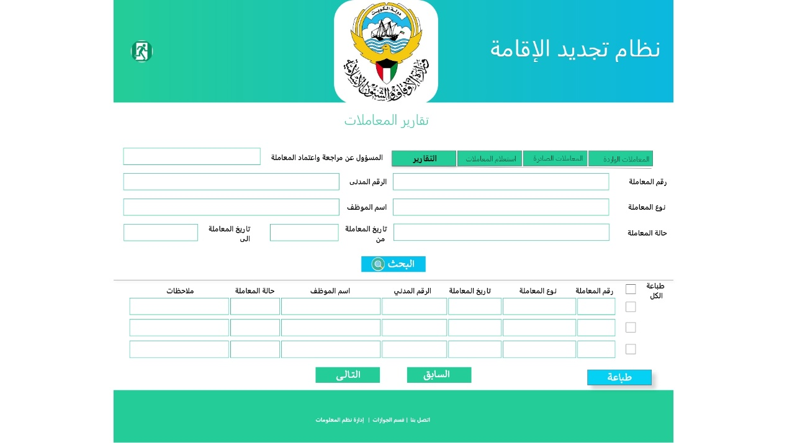

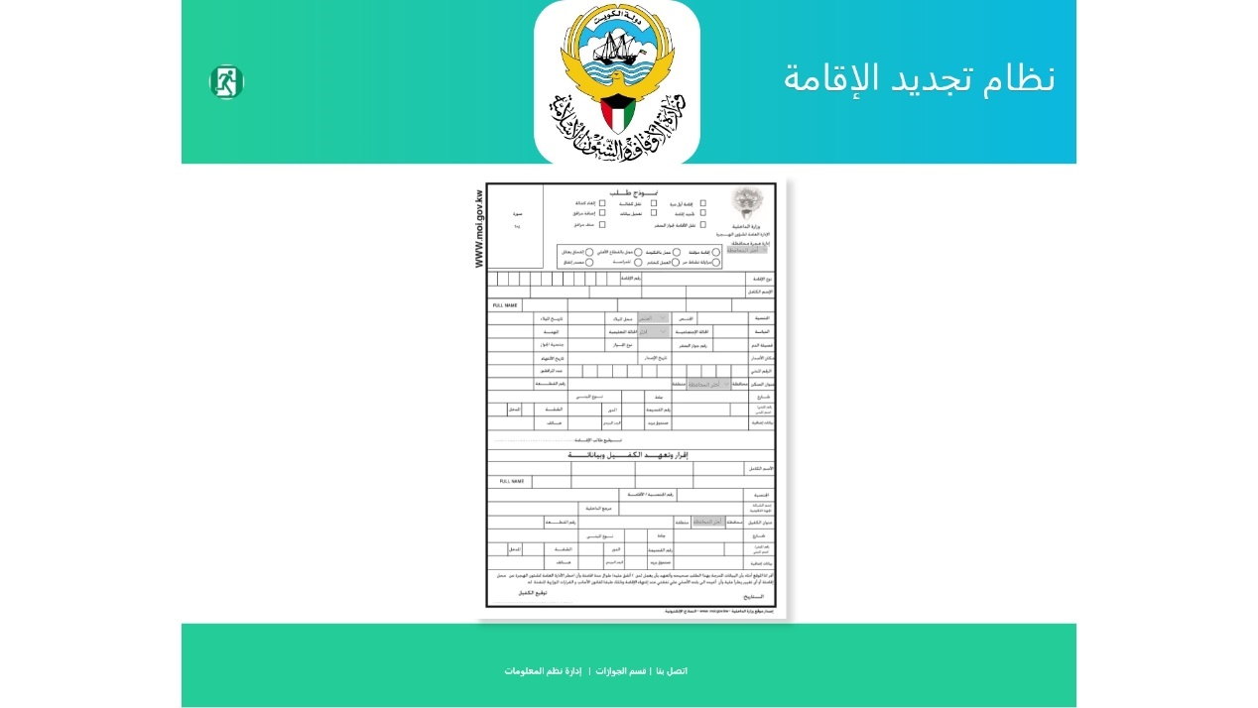

1. The System Manager can search for any Application for printing by entering any for the following search criteria or combination:

* Employee (Manger) who Approve/Reject the application
* Application Number
* Application Type
* Application Status
* Civil Id
* Employee Name (Arabic Name)
* Application Date rang (From – To)

1. This service will retrieve all Applications the required to be printed according to search criteria in following tabular Format:
   * Print All Check Box
   * Application Number
   * Application Type
   * Application date
   * Civil Id
   * Employee Name

* Application Status
* Remark

1. The System Manager can print all retrieved applications by check **Print All** option
2. The System Manager can print only the selected retrieved applications by check **Print** option beside each application
3. The following two Employee Performance reports required from this service as other reports:
   1. Summery Performance Report by range of Date (From – To)
      * Employee No, Employee Name Groped by (Employee, Application type, Approve , Reject )
        + Count of Application Type
        + Count for Approve
        + Count for Reject
        + Total Count for all Application
   2. Details Performance Reports by range of Date (From – To ) or All or selected Employee , Groped by (Employee , Application type , Approve , Reject )
      * Employee No, Employee Name,
        + Application number, Application Date, Applicant Name, Applicant Civil ID, Job Title

## System Setting

### Application Setting

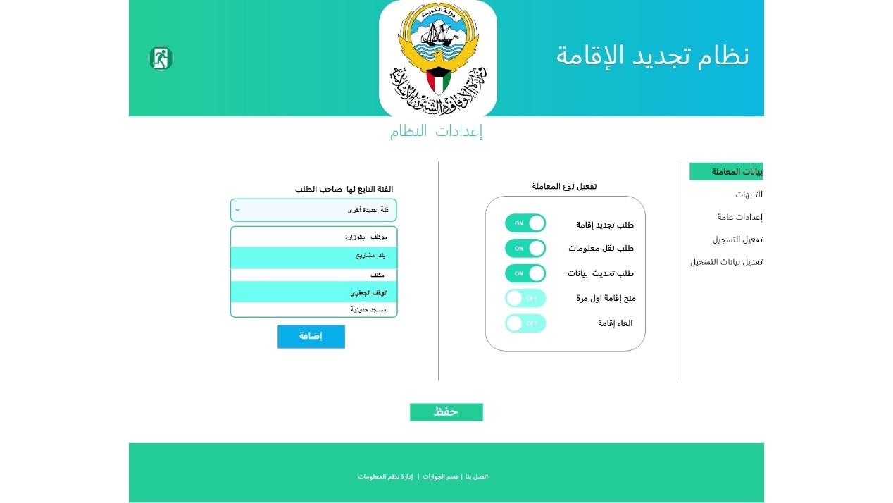

The System Manager can update / change the application data setting

* **Application Setting** Activate / Deactivate the following application Type (Services)**:**

|  |  |
| --- | --- |
| Arabic Field Name | English Field Name |
| تجديد إقامة | Renewal Residency |
| نقل معلومات | Transfer Information |
| تحديث بيانات | Update Information |
| تمديد إقامة | Extend Residency |
| الغاء اقامة | Cancel Residency |

*Note: The System should allow development team in future to Add new Application type (Add New Services) with minimum development efforts and time.*

* **Add new Employee Type to the following Types:**

|  |  |
| --- | --- |
| الفئة التابع لها الموظف | Employee Type |
| * موظف * مكلف * بند مشاريع * الوقف الجعفري * مساجد حدودية | * Employee * Charged * Projects team * The Jaafari Endowment * Frontier Mosques |

### Notification Setting

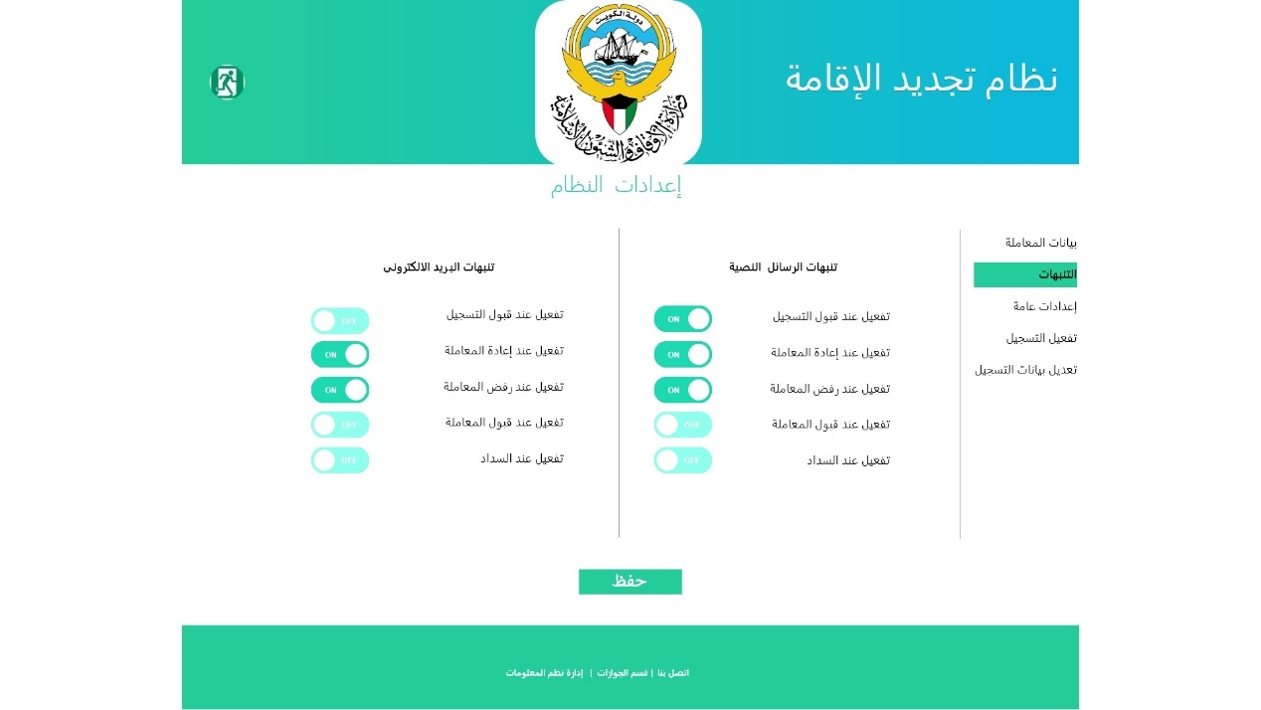

The System Manager can update / change the **Notification Setting**

* If the Notification **On**, the system will send Notification (Email / Mobile text Message) to the user (applicant), when any Change occurs in (Application status / Registration Status / Electronic Payment)
  + Activate / Deactivate Email notification for:
    - Registration Accepted
    - Application Approved
    - Application Rejected
    - Application Returned
    - Electronic Payment Done
  + Activate / Deactivate Mobile Text message for:
    - Registration Accepted
    - Application Approved
    - Application Rejected
    - Application Returned
    - Electronic Payment Done

### General Setting

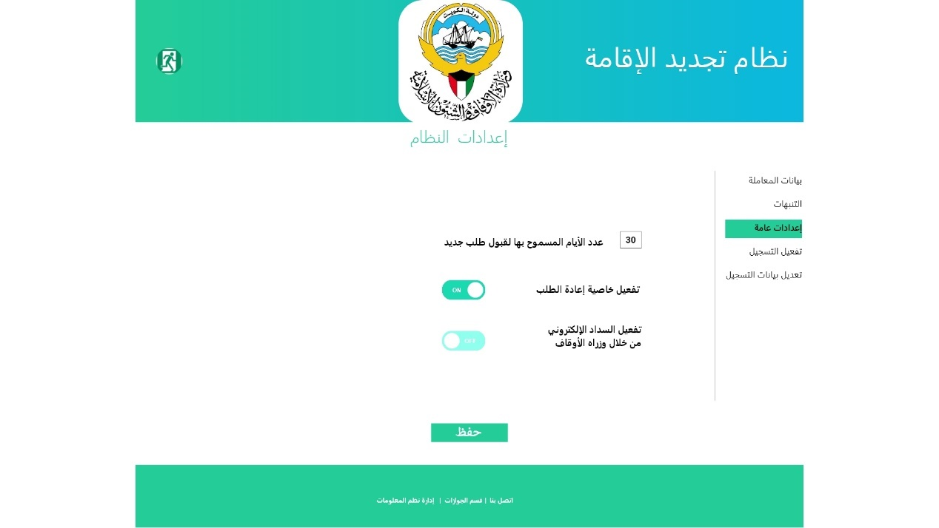

The System Manager can update / change the General setting

* **General Setting** :
  + Edit/update Number of days that allowed to create same **Application Type** for same user (Civil id)
  + Activate / Deactivate the **Return** function in application request
  + Activate / Deactivate Electronic payment by the user in last stage of create application (This function postpended until MOA-Administrative and Financial Affair sector approve it)

### Registration Activation

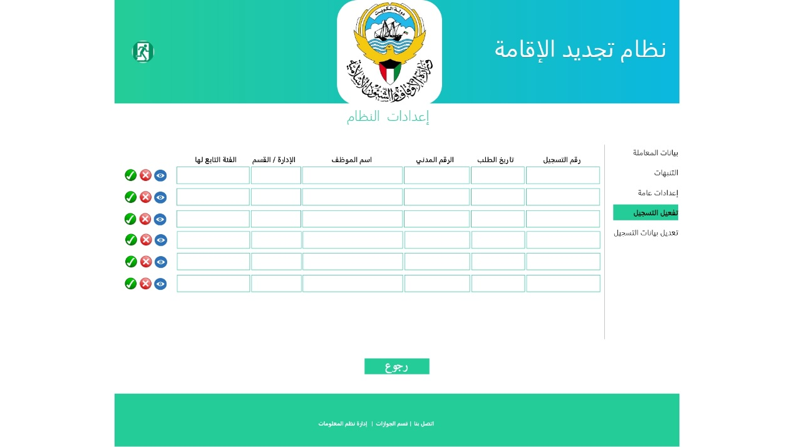

1. This service will retrieve all registration records with **New** Status in the following tabular Format:
   * Registration Number
   * Registration date
   * Civil Id
   * Employee Name
   * Department/ Section

* Employee Type

1. The Service will allow for system Manager to do one of following functions for each displayed record **(View**-**Accept -Rejected**)
   * View : The System manager can view the details of registration information for this record to and review the entire information for decision to **Accept** Or **Reject**
   * Accept : The System manager can Approve the registration record , so the user can login into the system
   * Reject: The System manager can reject the registration record for any reason, so the user can't login into the system.

### Updated Registered Information

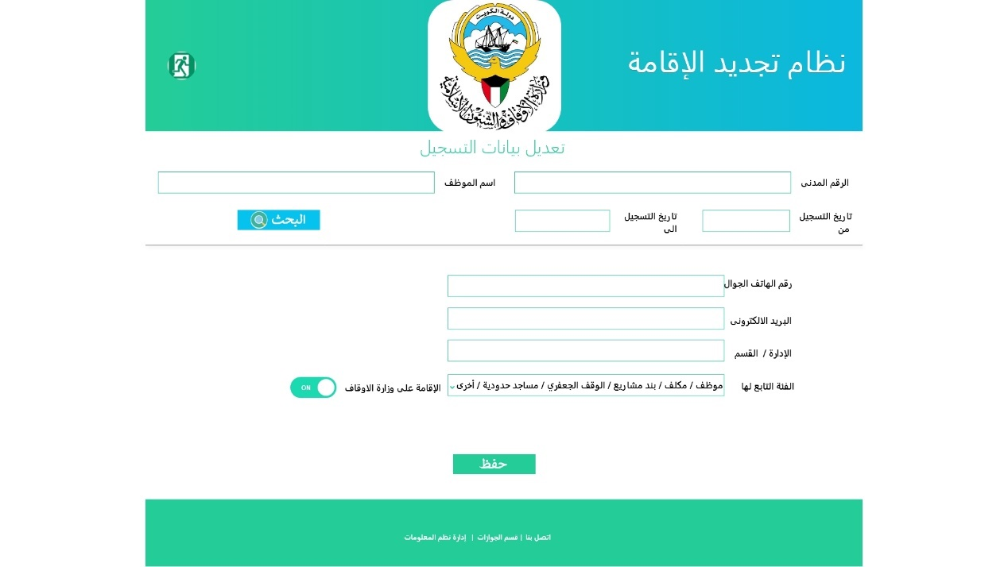

1. The System Manager can update registration record upon applicant request if applicant can't login to the front end or even can't reset his password
2. The System Manager can search for any record by entering any for the following search criteria or combination:

* Civil Id
* Employee Name (Arabic Name)
* Registration Date rang (From – To)

1. The System will retrieve the following information, So the system manager can update any of this information:

* Mobile Phone Number
* Email
* Sector / Department / Section
* Employee Type
* Residency by MOA
* Registration Status: dropdown list (New- Accepted -Rejected-Closed) list to closed status if system manager no longer needs such record

### Back End Business Rules for Setting

* Only MOA Front end users (exists in SAP HR database) with MOA email and password can login into system without registration and not allowed to registered with Civil ID or Email.
* The external Front end users (Not exists in SAP HR database) Only Can registered with external email (Not MOA email) and even his civil id shouldn't exist in (SAP HR database)
* The user with external email (Front end users) can login into front end system Only if his registered recode status is **Accepted**
* The System Manager is responsible for activate/de activate the registration all records by **Accept or Reject** it

Front End

Mob App

for

Residency Renewal

# **Front End Mob App for Residency Renewal Services**

## Login

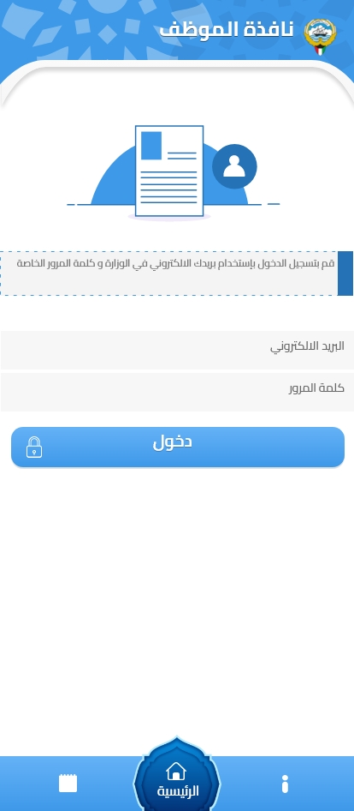

|  |  |  |
| --- | --- | --- |
| Type | Arabic Field Name | English Field Name |
| Mandatory, Textbox, Email Format, by Default its MOA Employee Email  Or  Register email in Residency Renewal System | البريد الالكتروني | Email |
| Mandatory, textbox, and password of MOA Employee Email  Or  The Register password in Residency Renewal System | كلمة المرور | Password |
| Action Button to login into Residency Renewal System  By default, any Employee has MOA Email and Password should login into system | **دخول** | **Login** |

## Initiate New Application

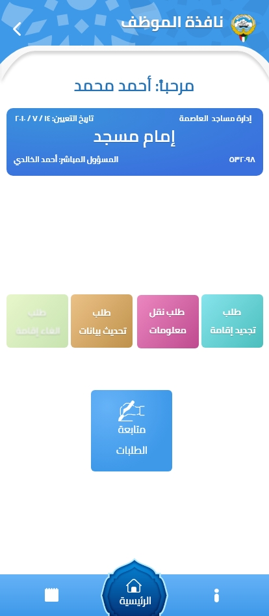

Page Header

|  |  |  |
| --- | --- | --- |
| Type | Arabic Field Name | English Field Name |
| Retrieved, Textbox, from login information | اسم المستخدم باللغة العربية | Emp. Name - Arabic |
| Retrieved, Textbox, from login information | الرقم المدني | Civil ID |
| Retrieved, Date Format | تاريخ التعيين | Hire Date |
| Retrieved, Textbox, from login information | الإدارة / القسم | Dept/Section |
| Retrieved, Textbox, from login information | المسؤول المباشر | Direct Manager |

Services

|  |  |  |
| --- | --- | --- |
| Type | Arabic Field Name | English Field Name |
| Service Button | تجديد إقامة | Renewal Residency |
| Service Button | نقل معلومات | Transfer Information |
| Service Button | تحديث بيانات | Update Information |
| Service Button | تمديد إقامة | Extend Residency |
| Service Button | الغاء اقامة | Cancel Residency |
|  |  |  |
| Service Button | متابعة الطلبات | Follow up the Application |

## Create New Application

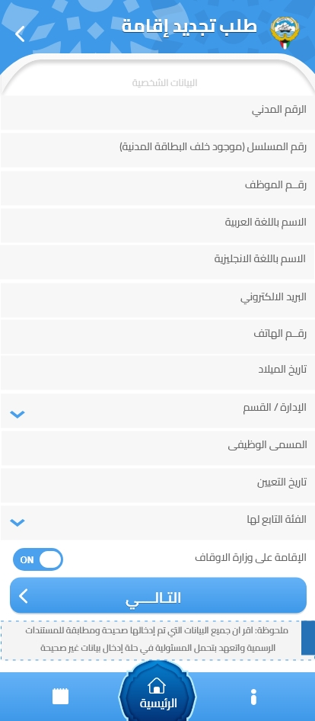

|  |  |  |
| --- | --- | --- |
| Type | Arabic Field Name | English Field Name |
| Mandatory, Retrieved, Textbox, from login information | الرقم المدني | Civil ID |
| Mandatory, textbox, valid serial Number from PACI and not less than 12 number | الرقم المسلسل للرقم المدني | Civil ID Serial Number |
| Auto Retrieved Employee Number from SAP HR System | رقم الموظف | Employee Number |
| Retrieved, Mandatory, Textbox, From PACI , and can be editable if not retrieved | الاسم باللغة العربية | Employee Name - Arabic |
| Retrieved, Mandatory, Textbox, From PACI , and can be editable if not retrieved | الاسم باللغة الانجليزية | Employee Name- English |
| Retrieved, Mandatory, Textbox, Email Format | البريد الالكتروني | Email |
| Retrieved, Mandatory with 9 number, and can be edit | رقم الهاتف | Mobile Number |
| Auto Retrieved, Date Format and can be editable if not retrieved  Should matched with Civil ID | تاريخ الميلاد | Birth Date |
| Auto Retrieved, Mandatory, Dropdown list (from SAP HR MOA organization structure) and Mandatory one value to be selected if not retrieved | الإدارة / القسم | Sector / Department / Section |
| Auto Retrieved, Mandatory, Textbox and can be editable if not retrieved | المسمى الوظيفي | Job Title |
| Auto Retrieved, Date Format and can be editable if not retrieved | تاريخ التعيين | Hire Date |
| Auto Retrieved, Mandatory, Date Format and can be editable if not retrieved | الفئة التابع لها الموظف | Employee Type |
| Mandatory Flag (Yes / No)  And System should allow to only Employee with Yes Flag to create new App. | الإقامة على وزارة الاوقاف | Residency by MOA |
|  |  |  |

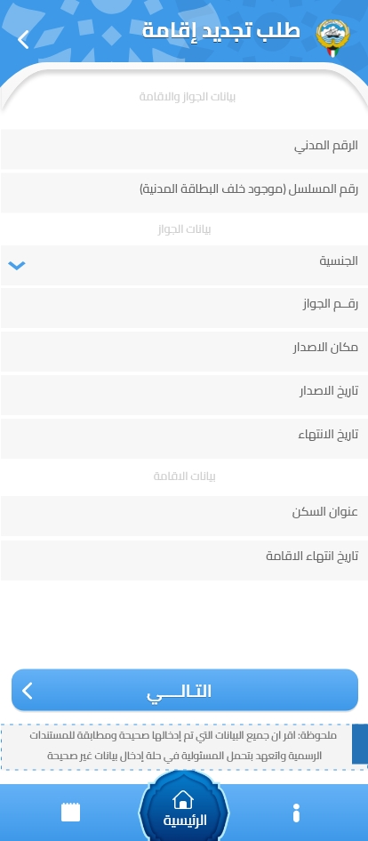

Passport Information Page Header

|  |  |  |
| --- | --- | --- |
| Type | Arabic Field Name | English Field Name |
| Retrieved the selected Application Type | نوع المعاملة | Application Type |
| Retrieved, Textbox, from login information | الرقم المدني | Civil ID |
| Mandatory, textbox, latest valid serial Number from PACI and not less than 12 number | الرقم المسلسل للرقم المدني | Civil ID Serial Number |

Passport Information Page

|  |  |  |
| --- | --- | --- |
| Type | Arabic Field Name | English Field Name |
| Auto Retrieved, and Dropdown list and Mandatory one value to be selected if not retrieved.  And System should allow to register only Employee with Non-Kuwaiti Nationality | الجنسية | Nationality |
| Mandatory, Textbox | رقم الجواز | Passport Number |
| Mandatory, dropdown Country List | مكان الاصدار | Issue Country |
| Mandatory, Date Format | تاريخ الاصدار | Issue Date |
| Mandatory, Date Format | تاريخ الانتهاء | Expiry Date |
| Mandatory, Textbox | العنوان | Address |
| Mandatory, Date Format | تاريخ انتهاء الاقامة | Residency Expiry Date |
|  |  |  |
| Validate all Mandatory Fields, Then Save information, Go to Personal Information Page | السابق | Pervious Page |
| Validate all Mandatory Fields, Then Save information, Go to Attachment Page Information | التالي | Next Page |

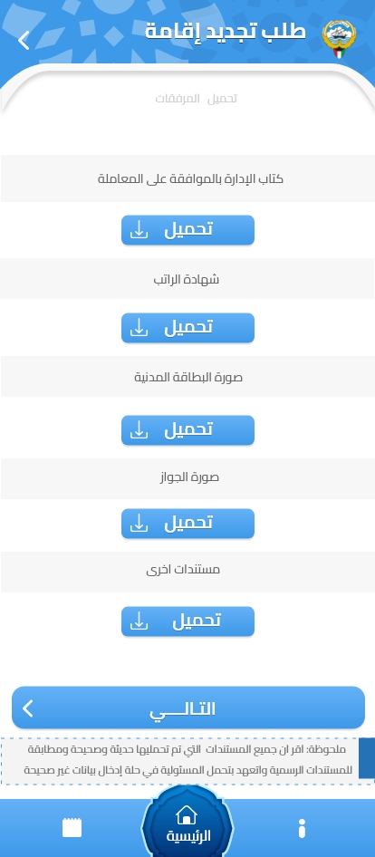

Attachment Document Page

|  |  |  |
| --- | --- | --- |
| Type | Arabic Field Name | English Field Name |
| Upload PDF,JPG,PNG,Word document Size not large than 1 MB | كتاب الإدارة بالموافقة على التجديد | Approved letter for Residency Renewal |
| Upload PDF,JPG,PNG,Word document Size not large than 1 MB | شهادة الراتب | Salary Certification |
| Upload PDF,JPG,PNG,Word document Size not large than 1 MB | صورة البطاقة المدنية | Civil Id Copy |
| Upload PDF,JPG,PNG,Word document Size not large than 1 MB | صورة الجواز | Passport Copy |
| Upload PDF,JPG,PNG,Word document Size not large than 1 MB | مستندات أخرى | Other related documents |
|  |  |  |
| Validate all Mandatory Fields, Then Save information, Go to Passport Information Page | السابق | Pervious Page |
| Validate all Mandatory Fields, Then Save information, Go to Agreement Page Information | التالى | Next Page |

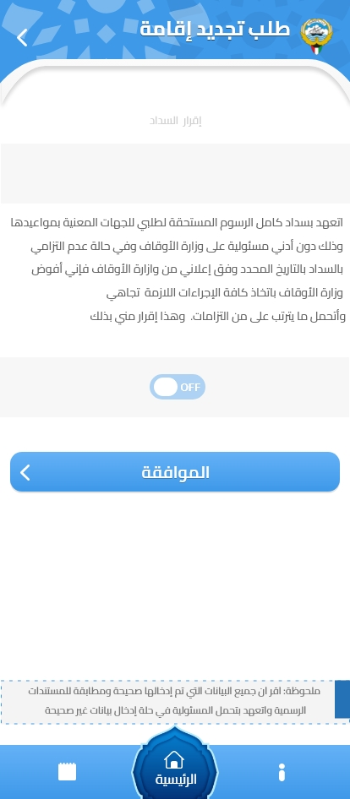

Once the user Complete Agreement page, the system will update the application status from Initiate to New Status and display the following information

* + Application Type as header
  + Civil Id
  + Employee Name in Arabic
  + -----------------------------------
  + Application Number
  + Application Type
  + Application date
* Application Status

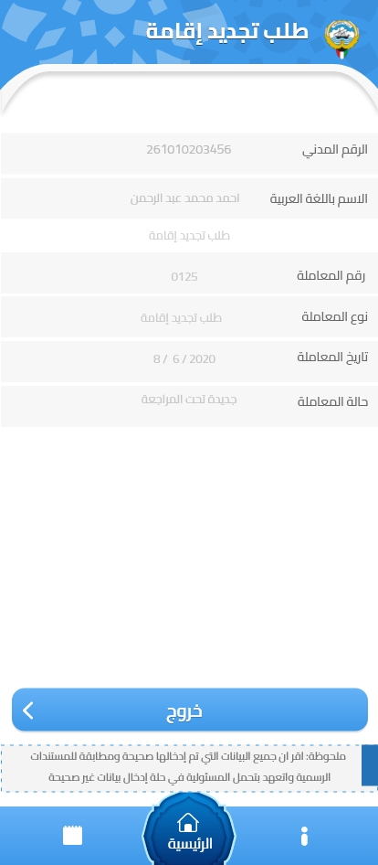

## Follow up Application

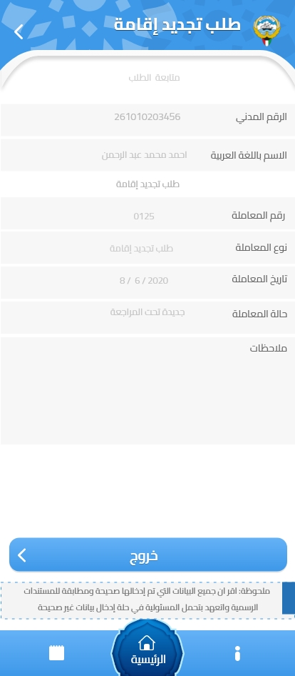

The user can follow up his application by select the follow up services and the system will display all his application in the following tabular From

* Civil ID
* Employee Name Arabic
* Application Number
* Application Type
* Application Date
* Application Status
* Remark

## Re-Edit Application

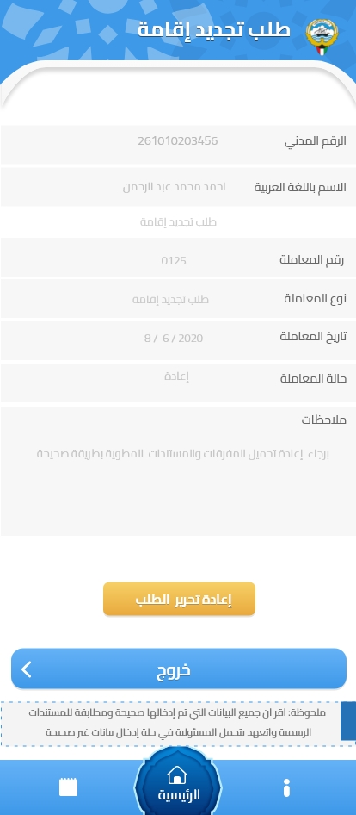

Once the application retuned for any reasons, the user can re-open hos application for edit using Re**-Edit Retuned Application** button

* + Civil Id
  + Employee Name in Arabic
  + -----------------------------------
  + Application Number
  + Application Type
  + Application date
* Application Status
* Remark ( The Reason for return )

**Re-Edit Retuned Application** button, should be enabled only in case application status (Return) and the user can re-edit and update his application by entering/update any missing information.

The system will update the application status from Return to Complete Status and display the following information

# **Back End Mob App for Residency Renewal Services**

## Manger Login

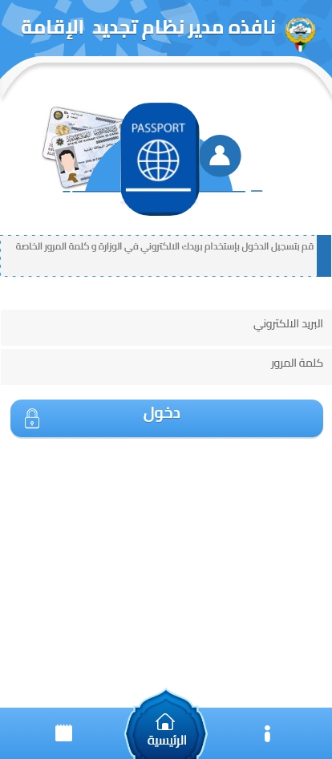

|  |  |  |
| --- | --- | --- |
| Type | Arabic Field Name | English Field Name |
| Mandatory, Textbox, MOA Email, MOA Employee for MOA-Administrative Affairs Department | البريد الالكتروني | Email |
| Mandatory, textbox, and password of MOA Employee Email | كلمة المرور | Password |
| Action Button to login into Residency Renewal **Back End** System according to granted security access | **دخول** | **Manager Login** |

## Application Information

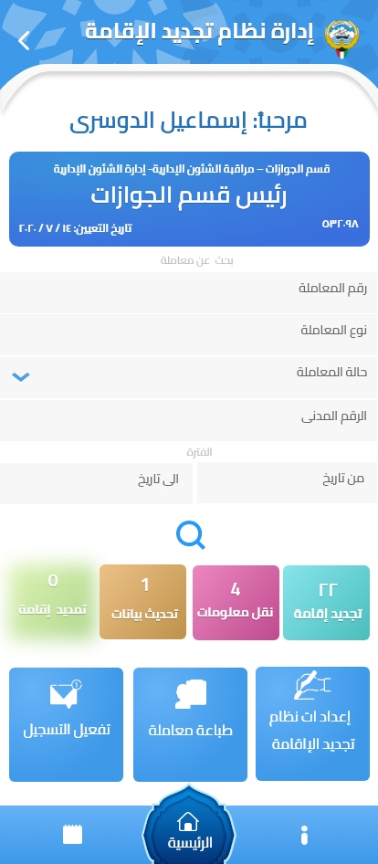

Page Header

|  |  |  |
| --- | --- | --- |
| Type | Arabic Field Name | English Field Name |
| Retrieved, Textbox, from MOA login information | اسم المستخدم باللغة العربية | Emp. Name - Arabic |
| Retrieved, Textbox, from MOA login information | الإدارة / القسم | Dept/Section |
| Retrieved, Textbox, from MOA login information | المسمى الوظيفى | Job Title |
| Retrieved, Textbox, from MOA login information | رقم الموظف | Employee Number |
| Retrieved, Date Format | تاريخ التعيين | Hire Date |

**Bank End Services**:

1. Application Search by any of the following search criteria:

* Application number
* Application Type
* Application status
* Civil Id
* Application date Range (From – To)

The Search Result will display **Requested Application** list

1. Application **Dash Board**

That Display the **Each Application Type** & The (New + Complete Application status) **Counts**

1. System Setting

That Control Residency Renewal system setting for:

* General setting
* Notification Setting
* Application Data setting

1. Registration Activation

That allow the system manager to review and Accept or reject any new user registration with external email to MOA.

## Requested Applications

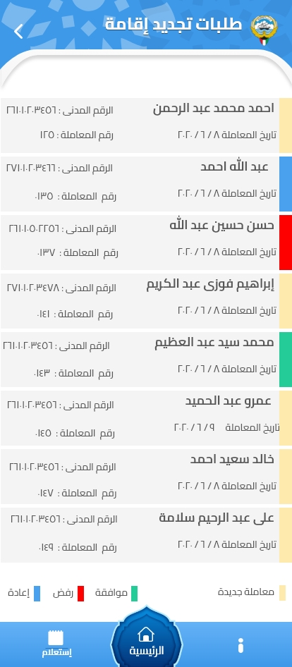

This list displays all Requests according to Selected Application Type or Search Result , The header display the Application Type.

|  |  |  |
| --- | --- | --- |
| Type | Arabic Field Name | English Field Name |
| Retrieved, Textbox, from Selected Application Type or Search Results | اسم المستخدم باللغة العربية | Emp. Name - Arabic |
| Retrieved, Number, from Selected Application Type or Search Results | الرقم المدني | Civil ID |
| Retrieved, Number, | رقم المعاملة | Application Number |
| Retrieved, Date-Format, from Selected Application Type or Search Results | تاريخ المعاملة | Application Date |
| Retrieved, textbox, from Selected Application Type or Search Results | حالة المعاملة | Application Status |

## Approve/Reject/Return Applications

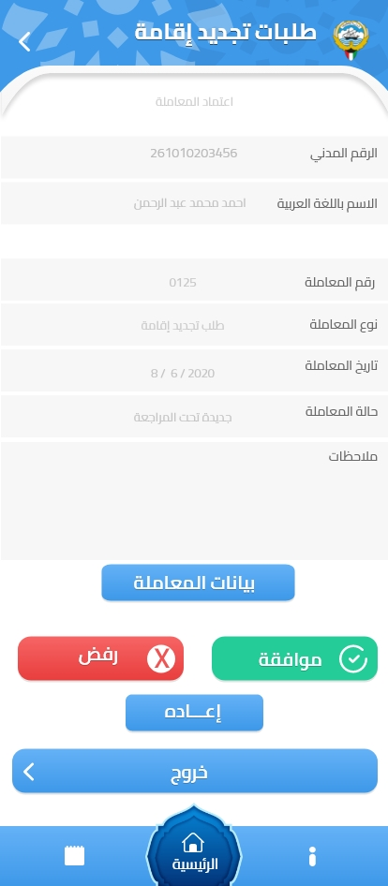

1. The Service will allow for system Manager to do one of following Actions on the selected displayed record **(View**-**Approve-Reject** -**Return**)
   * **View** : The System manager can view the details of the application information for review the entire application information and verify it for one of the following decision :
     + **Approve**: The System manager can review and Approve the application for the next stage ,update application status with **Approve** and notification sent to the applicant.
     + **Reject**: The System manager can Reject the application with valid reason for rejection and mandatory to update this reason in application Remark filed, update application status with **Reject** and notification sent to the applicant.
     + **Return**: The System manager can Return the application again to the applicant with detail reasons with any missing information required from applicant and mandatory to update this reason in application Remark filed, update application status with **Return** and notification sent to the applicant.
   * Exit : Return again to updated **Requested Application** list

## System Setting

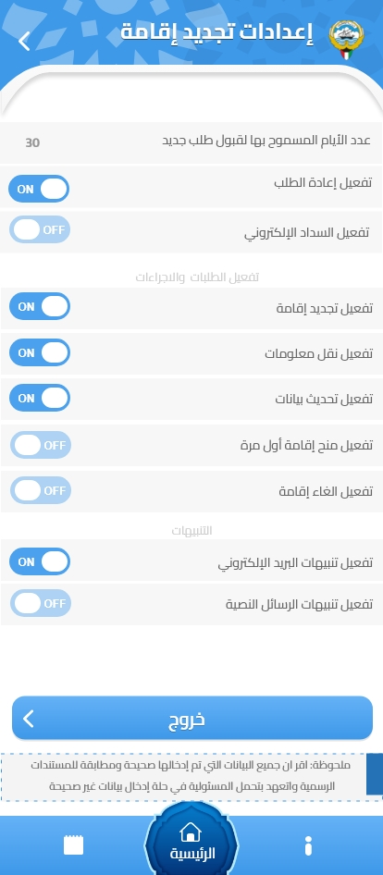

The System Manager can update / change the system setting

* **General Setting** :
  + Edit/update Number of days that allowed to create same **Application Type** for same user (Civil id)
  + Activate / Deactivate the **Return** function in application request
  + Activate / Deactivate Electronic payment by the user in last stage of create application (This function postpended until MOA-Administrative and Financial Affair sector approve it)
* **Application Setting** Activate / Deactivate the following application Type (Services)**:**

|  |  |
| --- | --- |
| Arabic Field Name | English Field Name |
| تجديد إقامة | Renewal Residency |
| نقل معلومات | Transfer Information |
| تحديث بيانات | Update Information |
| تمديد إقامة | Extend Residency |
| الغاء اقامة | Cancel Residency |

* **Notification Setting** for any Change in (Application status / Registration Status)
  + Activate / Deactivate Email notification
  + Activate / Deactivate Mobile Text message

## Registration List

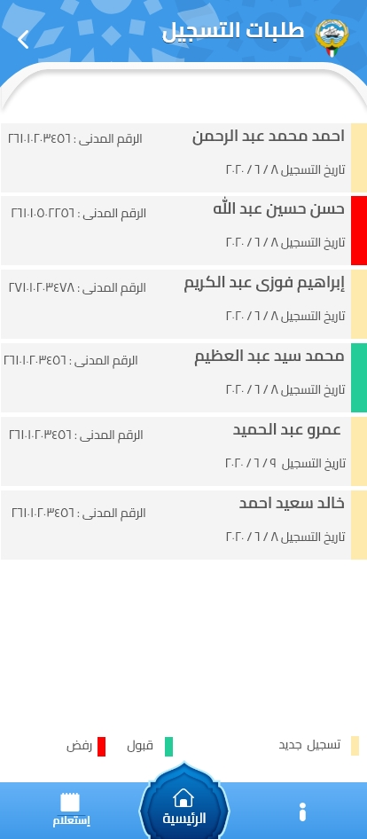

1. This service will retrieve all registration records with and list each new record in the following Format:
   * Registration Number
   * Registration date
   * Civil Id
   * Employee Name
   * Registration Status



## Registration Activation

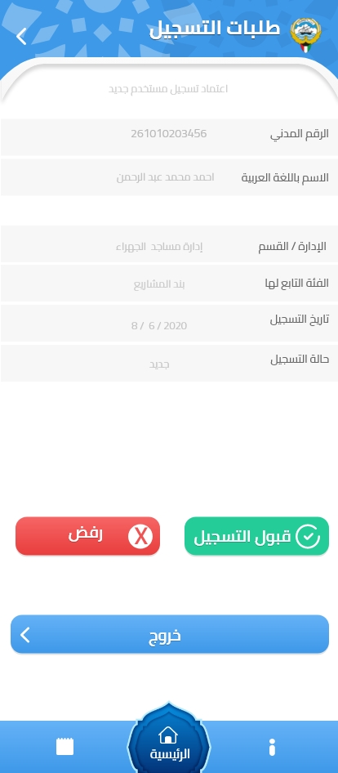

1. If any record selected from Registration list the system will display the following information:
   * Civil Id
   * Employee Name - Arabic
   * Registration Number
   * Registration date
   * Registration Status
   * Department/ Section
   * Employee Type
2. This Service will allow for system manager to do one of following actions for each displayed record **(Accept -Rejected**)
   * Accept : The System manager can Approve the registration record , so the user can login into the system with external Email to MOA.
   * Reject: The System manager can reject the registration record for any reason, so the user can't login into the system.